**Experiment 1B**

**Creation of Cloud9 Environment**

1.Go to the amazon console page.

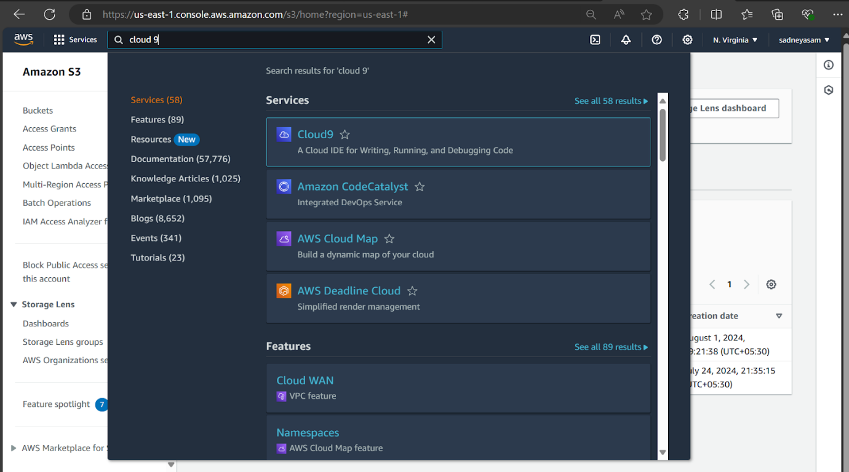

2.click on create environment.

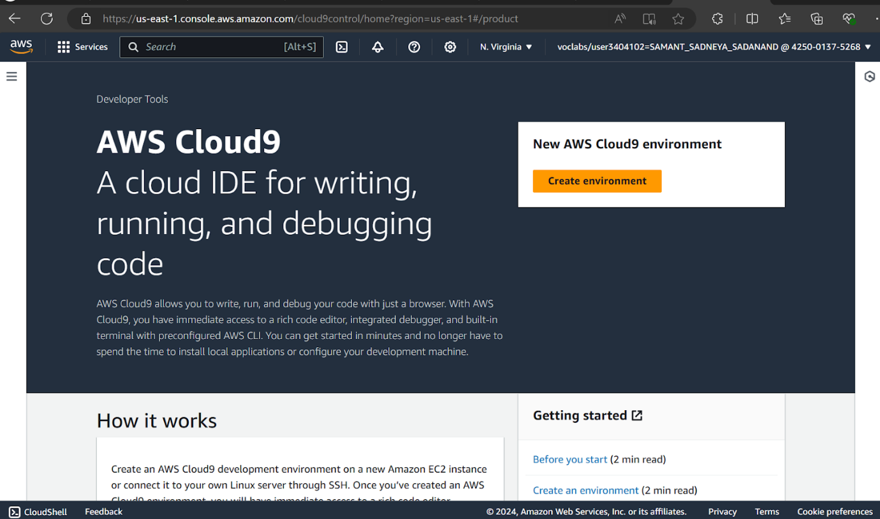

3. Give the name to your environment. Here I have given the name as sadneya_46. keep the remaining things by default.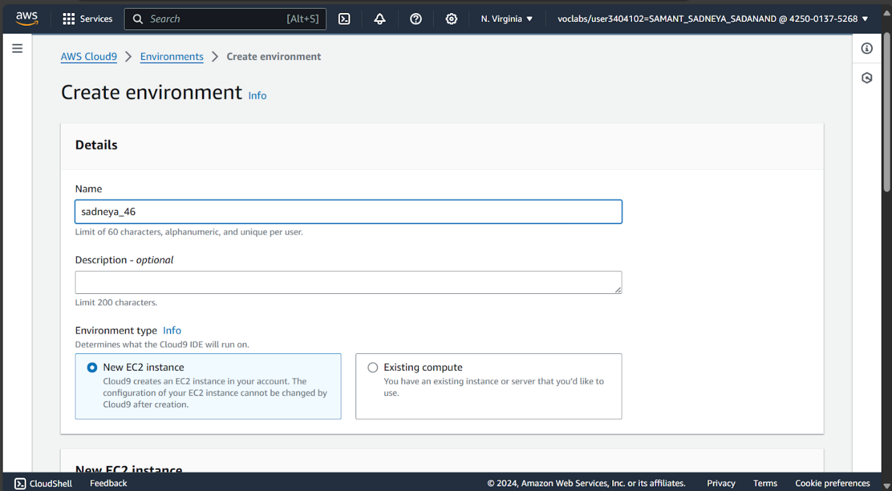

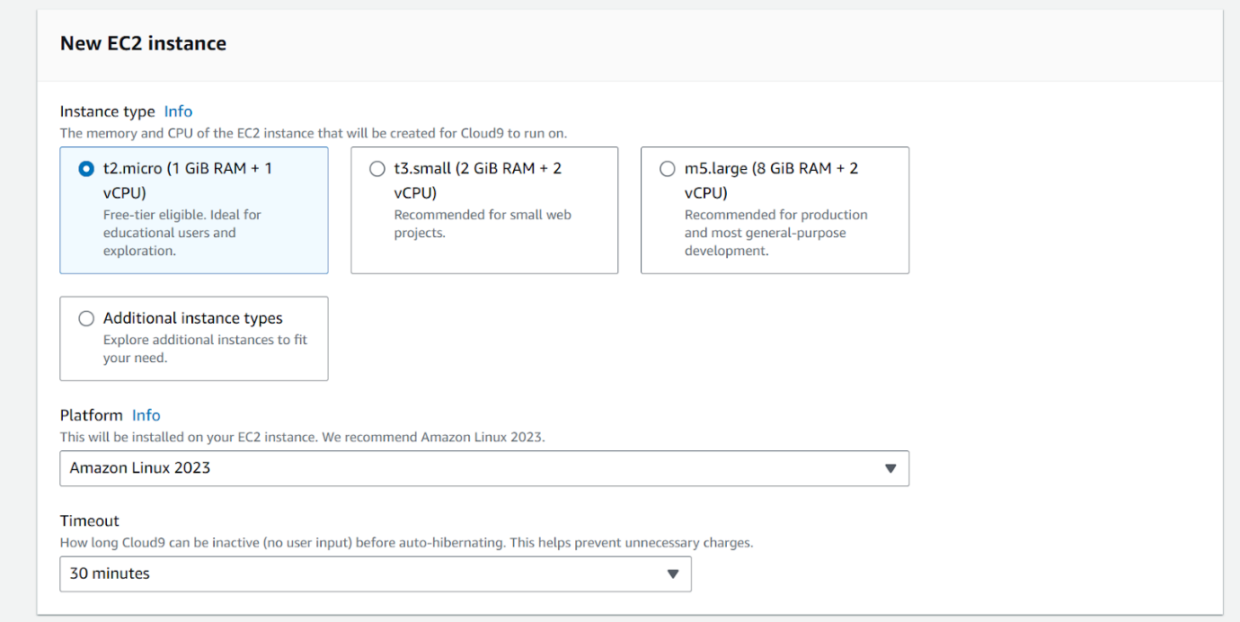

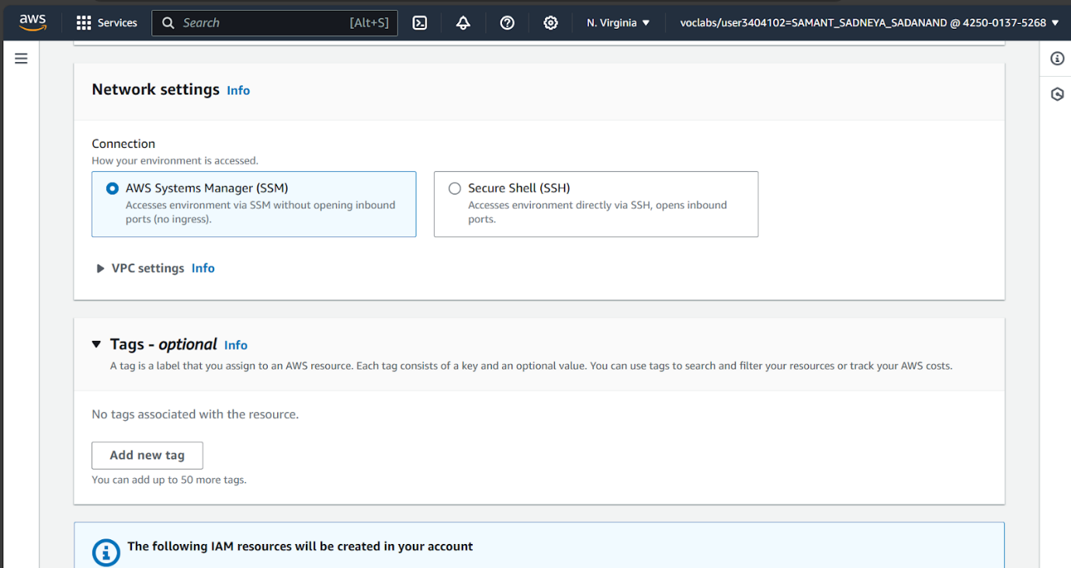

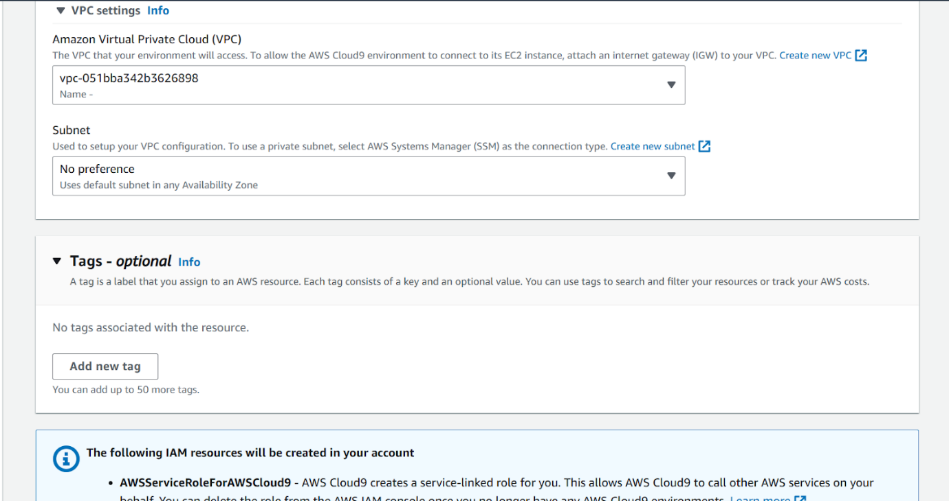

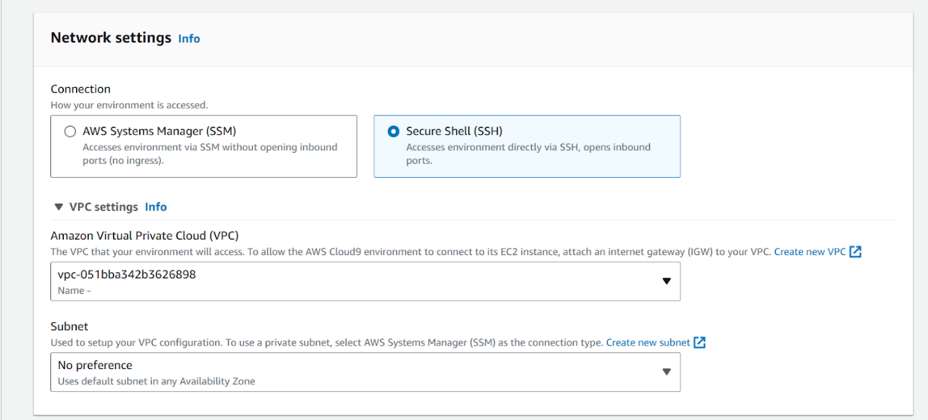Thus, the environment was created.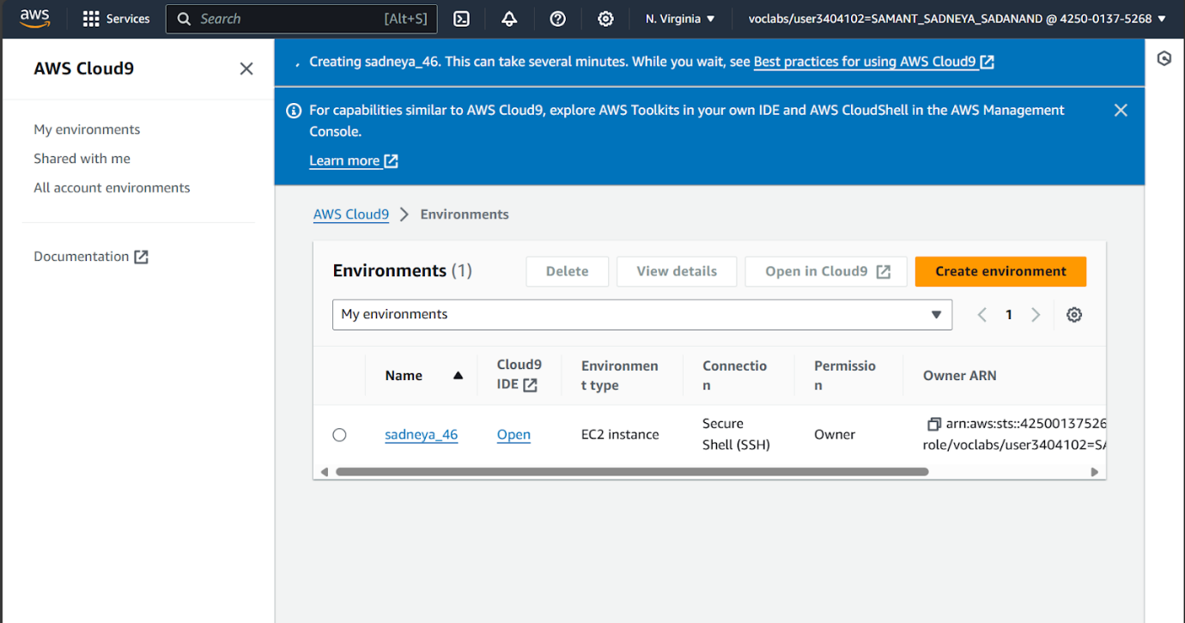

**Creation of I am user**

1. Go to I am.

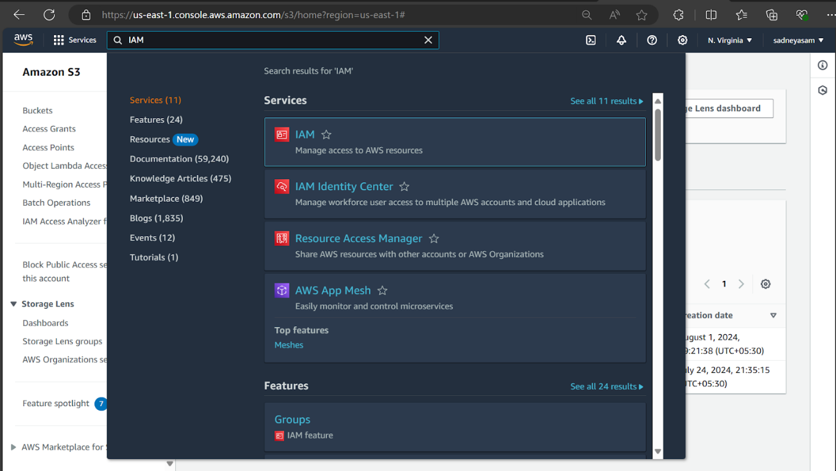

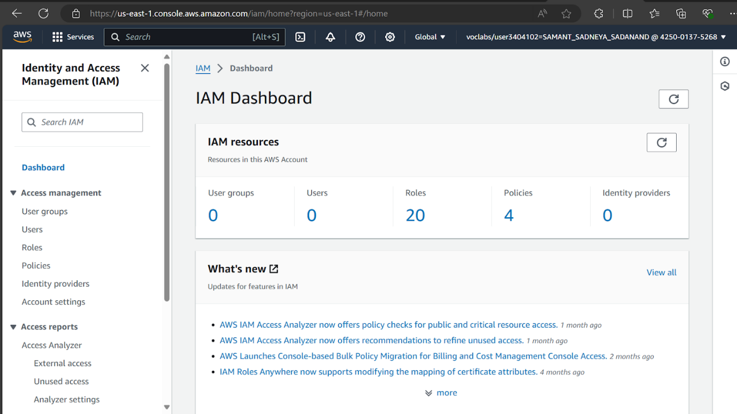

1. Select Users here.
2. Then Click on create user.

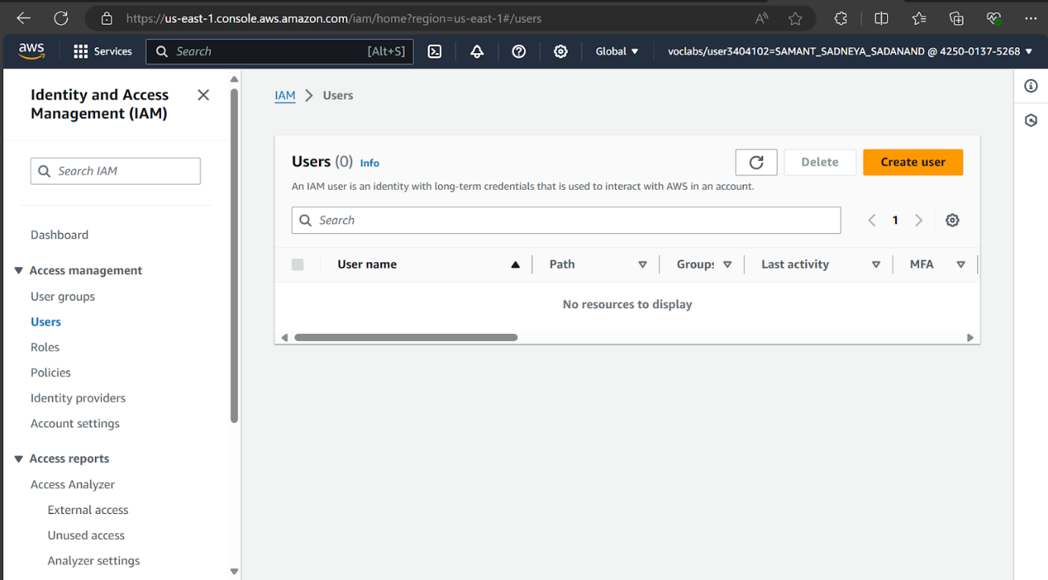

4. Give I AM user name. Here I have given it as sadneya_46. Select custom password and enter your password.

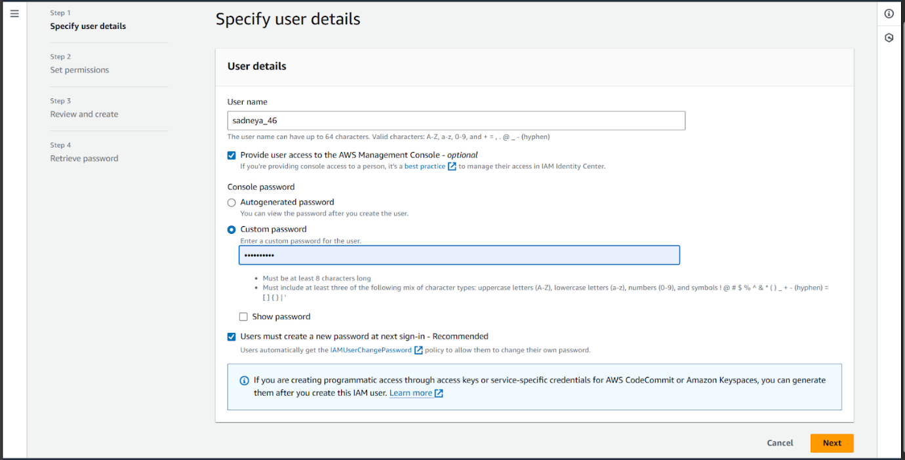

1. Select Add user to group. And click next.

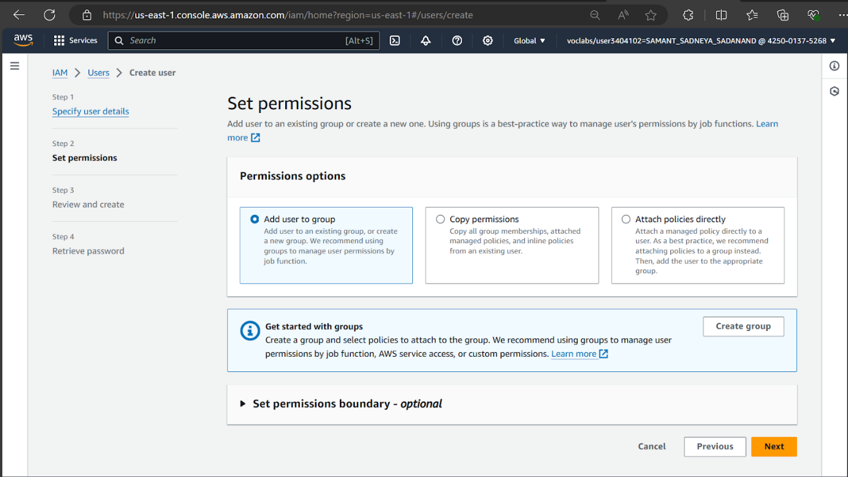

1. Also select permissions. Here I have selected AWSCloud9EnvironmentMember for cloud9 Environment. then click on next.

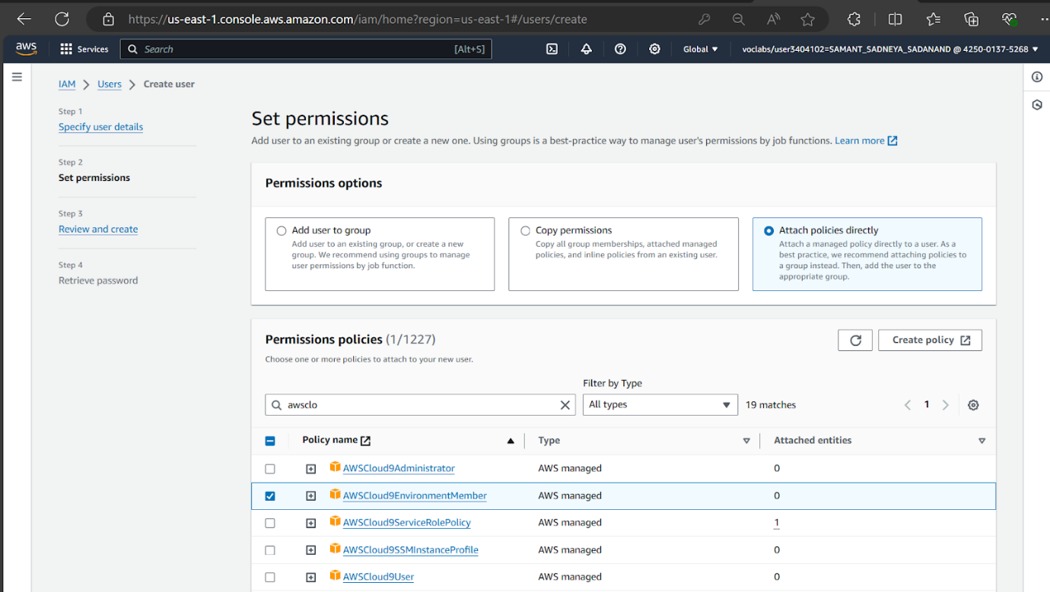

To add user, we need to create

1. To create a user group, give it a name as WebAppUser.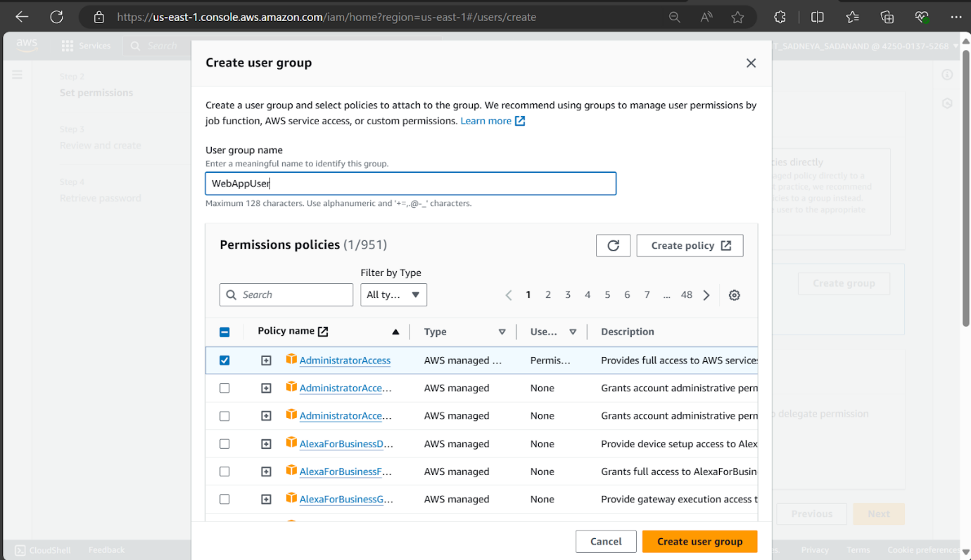
2. Thus, WebAppUser get created successfully.

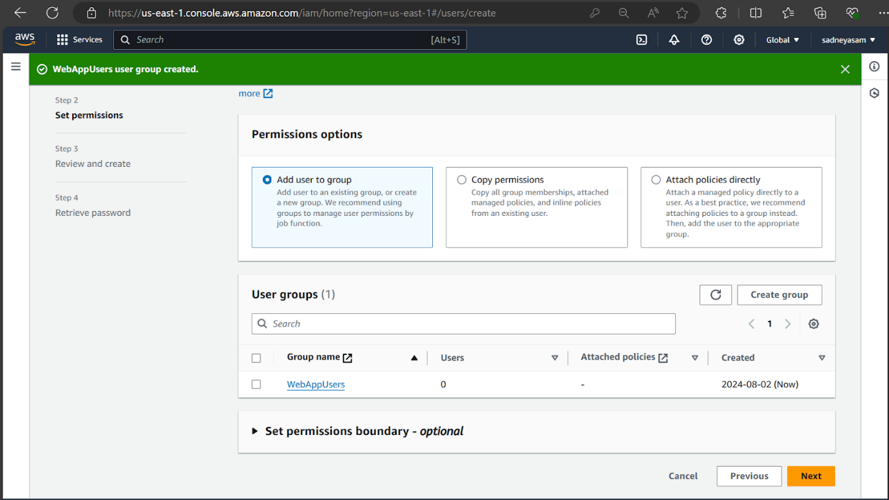

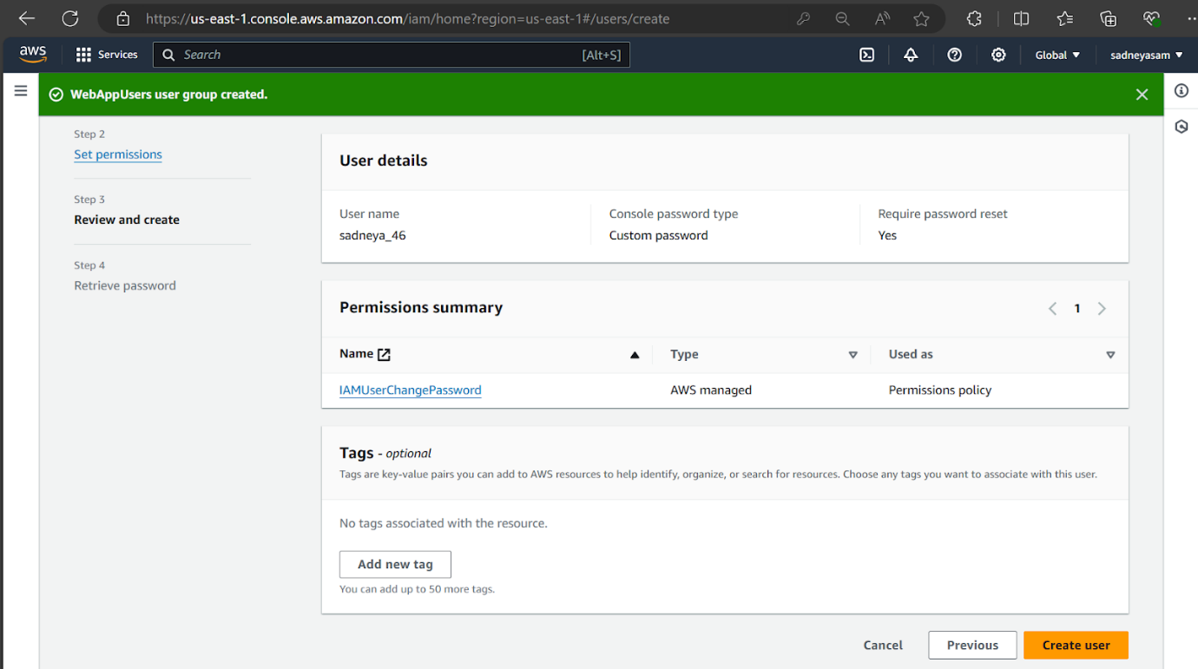

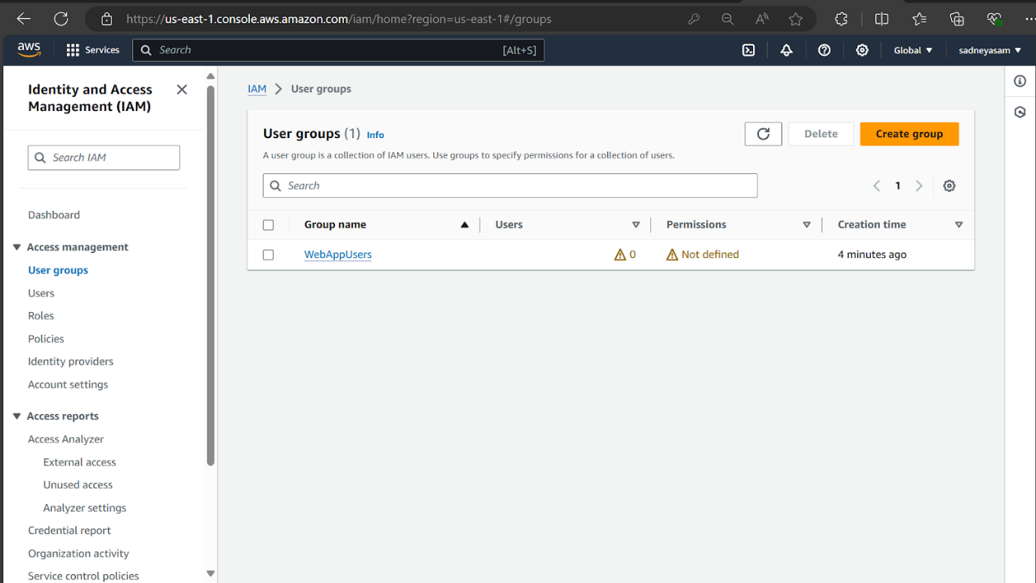

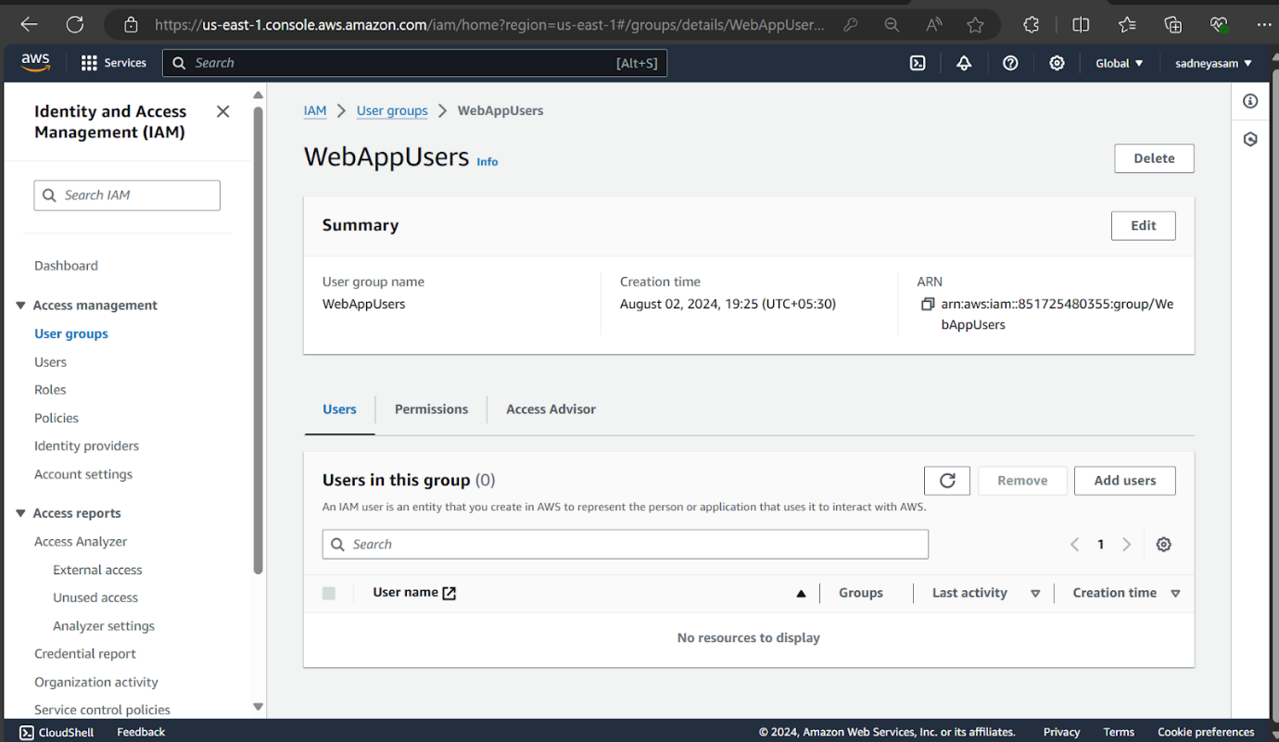

1. Then click on next and thus the user gets successfully created.

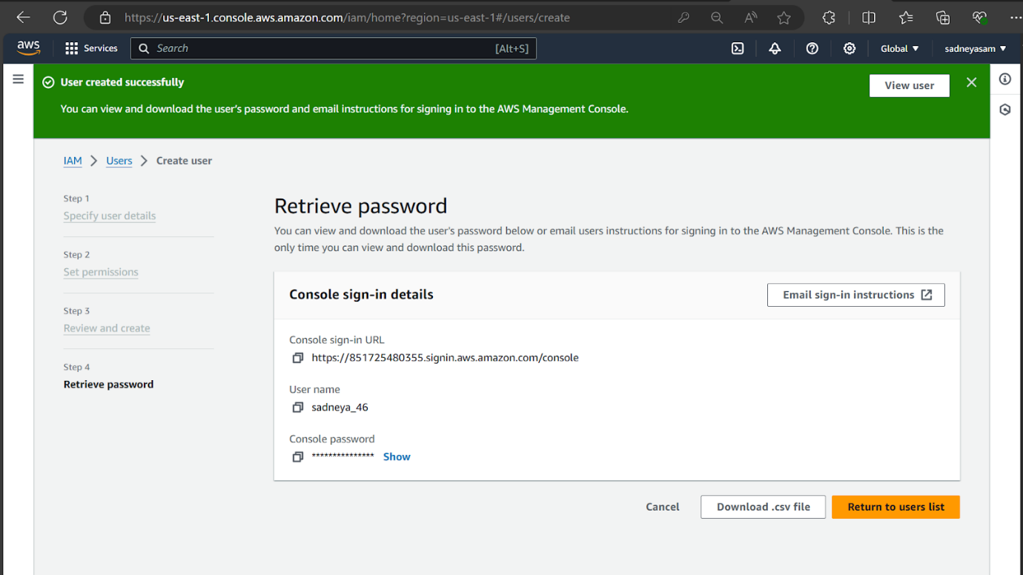10. This is a summary of user created.

